Answer 3
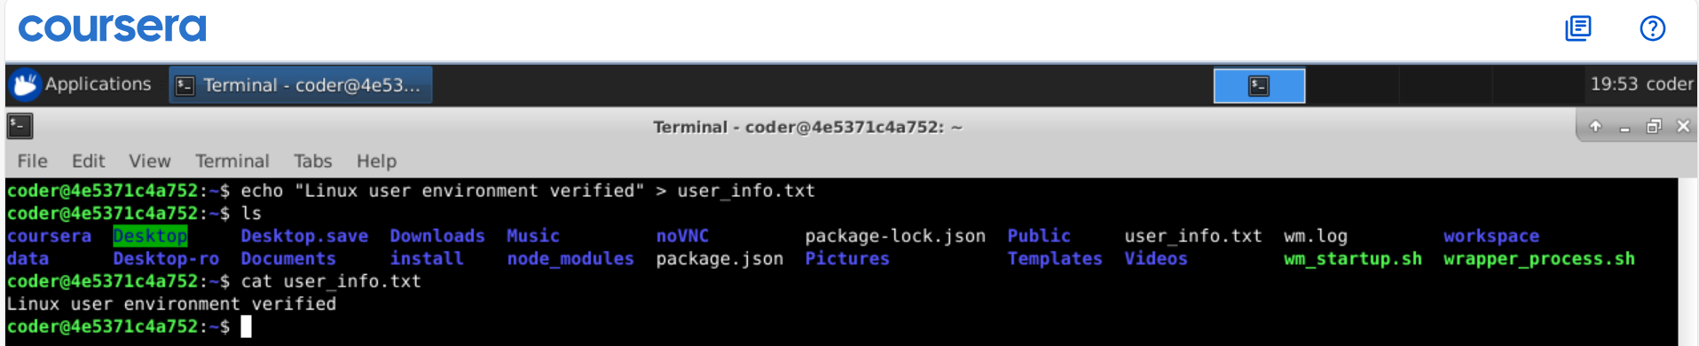
Explanation: Using echo “Linux user environment verified” > user_info.txt, it creates a file name user_info.txt and adds the output come from echo command into the file and later using cat command I am displaying what’s inside the file. By using >> we can append to the file later if we want to add more files to it.

